Biology – Chapter 2

The Chemicals of Life – Where is my learning at? Can I do the following?

 | Red | Orange | Green
What is a biomolecule?
Name the 4 biomolecules needed by organisms
Give a good source of
- Carbohydrates (starch, sugar, fibre)
- Protein
- Fat
- Vitamins (C and D)
- Minerals (Calcium and Iron)
Give the functions of
- Carbohydrates (starch, sugar, fibre)
- Protein
- Fat
- Vitamins (C and D)
- Minerals (Calcium and Iron)
What is the function of water in the diet?
Food tests – for each food test
- Describe how to treat the food before testing (grind up and mix with water)
- Name the chemical
- Say if heat is required
- Give the original colour of the chemical
- Give the final colour of the chemical if there is a positive result
What is a balanced diet?
Know that a person’s balanced diet depends on age, gender, level of activity and general health
Be able to read a food label and compare two food labels for amounts of energy and food types per 100g
What information does Reference Intake give about a food?
What is the food pyramid?
Be able to describe the food pyramid and how to use it.
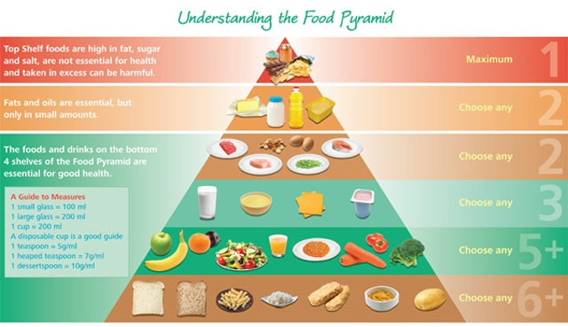
 | Red | Orange | Green
What is malnutrition?
What is a disease?
What is a deficiency disease?
Name the deficiency diseases that result from a lack of
- Vitamin C
- Vitamin D
- Iron
- Calcium
Describe a dietary cause and symptom of the following diseases:
- Obesity
- High Blood Pressure
- Type 2 diabetes

Key Words for this topic
(A key word is a word which you must be able to explain (give a definition of), use in a sentence, understand what it means when it is used in a question and if it is part of a diagram you need to be able to draw or label it.)
Biomolecule | Carbohydrate | Protein
Fat | Vitamin | Mineral
Balanced diet | Reference intake | Food pyramid
Malnutrition | Disease | Deficiency disease

