Biology – Chapter 1

The Organisation of Life – Where is my learning at? Can I do the following?

 | Red | Orange | Green
What is an organism?
List the seven characteristics of Living things
Describe each of the seven characteristics
Explain Respiration
Explain Photosynthesis
Look at an object and say if it is living or non living
Know that organisms are made of cells
Cells are viewed using a microscope
Label the microscope
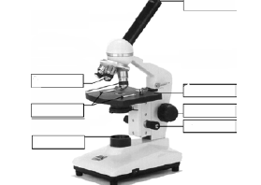

Give the functions of the parts of the microscope
Calculate the magnification depending on what objective lens is in position
Calculate the magnification of the microscope if the objective lens is 4X and the eyepiece lens is 10X
Describe in detail how you would prepare and examine onion cells
What stain do you use to stain plant cells?
Why do you use a cover slip?
Describe how you put a cover slip on a slide
Draw and label and plant cell
Draw and label an animal cell
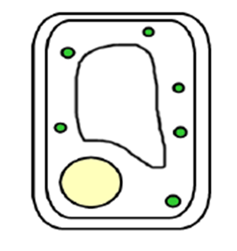
Which one of these is a plant cell and which is an animal cell?

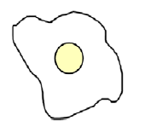
 | Red | Orange | Green
What is an electron microscope?
How is an electron microscope different from a light microscope?
What is a micrograph?
Explain how living things are organised (cells, tissues, organs, systems)
Say what the following terms mean (Define them):
Organelle
Cell
Tissue
Organ
System
Organism
Population
Community
Ecosystem
Ecology

Key Words for this topic
(A key word is a word which you must be able to explain (give a definition of), use in a sentence, understand what it means when it is used in a question and if it is part of a diagram you need to be able to draw or label it.)
Organism | Characteristic | Nutrition | Respiration
Excretion | Growth | Reproduction | Movement
Response | Sensitivity | Organisation | Tissue
Organ | System | Population | Community
Ecosystem | Ecology | Microscope | Micrograph

